The Yellow Deli,just another cafe?
The Twelve Tribes-owned and run
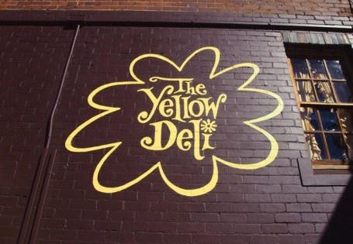
Yellow Deli/Common Ground Cafes
viewed as a commercial entity, their goals and ethics.

There exists standards that providers of goods and services are expected to adhere to in regards to how they go about selling their products. Part of that standard requires proper labelling so that people are given an opportunity to be fully informed of its content. As such, failure to accurately represent the product and its usage may be grounds for the consumer to lodge a dispute with relevant entities that protect consumers rights or and if found guilty, the manufacturer/provider may face having to pay punitive damages.

Also if you have problems with a service provided or find fault in the product you bought you are entitled to being heard and have the problems resolved or goods fixed. You can get your money back.
Should we expect any less from religions? Of course not! Whereas most comply with such a standard this is not always so. As is the case with the religion/industry named ‘Twelve Tribes: Commonwealth of Israel’.

Religions demanding from their adherents what is viewed by society as eccentric or extreme, will often resort to deception and obfuscation so as not to deter potential new recruits. Only after a period of time, after the new recruit has made a commitment; in some cases having handed over all their possessions, including their right to self-determination, is a full understanding of their religious dogma gradually revealed to them. By such time the trap has well and truly snapped shut.
A Twelve Tribes recruitment centre
The Yellow Deli in Katoomba Australia

So, let’s take a close look at the Yellow Deli and the religious group behind it called the Twelve Tribes

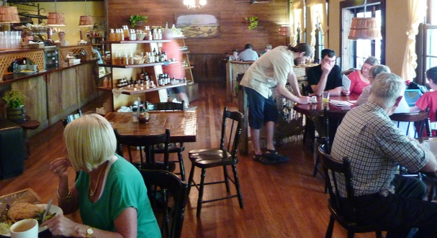
Most people who come in contact for the first time with members give a glowing report. They seem like such a friendly, harmless, peaceful bunch. They are ready to please their customers and offer old fashioned courtesy. Their cafes have been compared by many to a tree house in the woods, a haven to run to away from the hustle and bustle, even a kind of sanctuary. And who needs to mention their tasty food? Everyone loves it. Well done Twelve Tribes, you do make an impression on people. All the hard work, sincerity, incessant labour doesn’t go unnoticed nor is unappreciated.

Credit where credit is due, the TT are full of well-meaning, idealistic zealous people who have given everything a person could possess away in exchange for a life dedicated to what they believe will mean the end of suffering, war and injustice in the world. Many people see them as zealous Christians, envying them for taking steps they wouldn’t have dared to take themselves, as one thinks of a missionary in a foreign land, suffering every hardship for the good of others. And this is exactly who they think they are, a special group of people hand-picked by God for a very important mission.
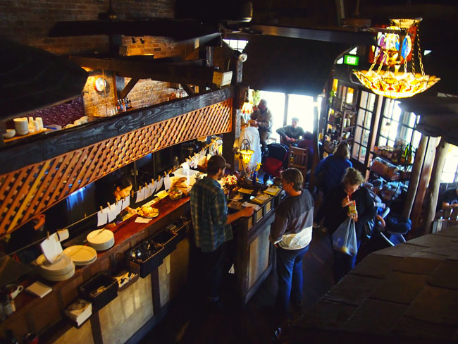

So of course the Common Ground Cafe is not an ordinary Cafe nor are the people who work there ordinary. An ordinary business or enterprise works for the main goal of making a profit, employing people and providing goods and services. And what is the main goal of the TT in carrying out their business? Look past the sandwiches and the smiles, observe, read their publications, ask around, talk to them and you will find something quite different. First they work for no pay. Are they volunteers working for a charitable association? No, not really, they charge for everything like any other cafe would and they don’t provide any other special service to the community at large like so many charities or not for profit associations do. Well, just ask them yourself, it’s not a mystery, in fact they even are quite proud of it; they have, would and still will continue running cafes everywhere not mainly to generate an income but to recruit new members. They think they are doing what Jesus told his disciples to do which is to be fishers of men and cast their nets as far and wide as they can to catch as many fish/people. The cafes are the nets. Locations for their permanent cafes are picked for their constant flow of travellers, tourists or students, all potential recruits. And that is why they have mobile cafes or bring their Peacemaker bus to festivals, concerts and Christian gatherings,etc

So what is their main drive, motivation or agenda?

In their own words they are carrying out Yashua’s will on earth which is to find those willing to give up everything for Him. They are “seeking their lost brothers and sisters”, “gathering the lost sheep”. Sounds like a Christian mission. But it is not. The difference is that they believe their way is the only way to truly please God. So they are not seeking to connect with other link-minded people nor with other fellow Christians. In fact they abhor Christianity and do not truly respect any other philosophies or points of vue on anything.
Yes, their sole purpose is to recruit people, young and old by converting them to their ways and traditions. They want you. The other cafes just want your money in exchange for food and service. The TT want you, which in the context of their beliefs and practises precisely mean: YOU=your physical body, your mind, your abilities, your time 24/7/365 until you die, your connections, your friends, your partner, your children, your car, all the money in the bank + any you would inherit or access later or that you have willed or will to your family or children + your house, land, possessions. It will also cost you your dreams, your freedom, your independence. You’ve got it: EVERYTHING.

So, since they want so much from you and those you care about please take the time to examine their goods and services with more scrutiny than you would from another cafe.
Let’s look at the goods being advertised.

WE HAVE BUT ONE LEADER: OUR MASTER YASHUA
What they tell you or in commercial words advertise is that each member has a direct connection to Yashua (Jesus) who is the source of all love, knowledge, truth. Based on that everyone is free to live out their faith and all have a say and contribute to the group. They also advertise that they have not one man as their singular head of government of their nation ( New Israel) but that each of the 12 Tribes functions autonomously.

Just ask those who have spent time among them and those who have studied them and they will tell you the real story. They will describe a pyramid system with one guy called Yoneq at the top writing all the doctrines and traditions and enforcing them all the way down to the last child in every household in the world where they live through a very strict and elaborate hierarchy. This is not obvious to the uninformed and yes, sadly, even to the average member. What we mean is, they acknowledge there are clearly defined authority figures and positions within their group. But for the most part the mind control they are under doesn’t allow them to see the ultimate reality of who is actually in control. They will tell you candidly that Yoneq (Eugene Spriggs is his real name) is only one of the many leaders and that everyone has a voice and a say.
Yoneq and Ha Emeq

WE ARE FREE TO BE WHAT WE WANT TO BE AND SAY WHAT WE WANT TO SAY
They will tell you like a dreamer dreams with wide open eyes that their life promotes freedom of expression and that you get freed to be whom you really want to be and do what is really in your heart.
Beautiful and attractive perspective you could say. Catchy advertisement for anyone needing a change in their life, don't you think? Look a bit more deeply and ask those who have friends and family in the group. They will tell you that group thinking prevails and their friend or brother changed from day one and are now many years later all the more the reflection of the ways dictated by the group. You will hear that people who disagree even slightly with the leaders or the doctrines get shunned, ostracized and if persisting, expelled.

WE SERVE A GOD OF JUSTICE AND FAIRNESS, IMPARTIAL AND FULL OF EQUITY.
In all modesty they will try to convince you that the TT are well on their way of being the only genuine representatives of this just and fair God. They proclaim being free from any social economic barriers, and that amongst them true justice can be finally found.

Well, where do you find the true customers of the Common Ground Cafe, those who bought the goods that the TT ultimately promotes and sells? What do those who exchanged their whole YOU for that wonderful life in the TT have to say? What about those who had no choice because they were born in there? They will tell you that their God must be partial for there are those who obviously are his favourites. Those ones get the best treatment, don’t work as hard if at all, get to shop around with their own money and buy expensive or fancy items and their kids seem to always get more attention and respect than the others. They also enjoy many freedoms the rank and file members can only dream of. Yes sadly this “brand new culture” they advertise is just as flawed as any other.

They will also tell you that according to the TT there is absolutely no valid reason for leaving. You are expected to bite the bullet, take the blame for everything and stay there no matter what is thrown at you. The doctrines and traditions (all coming from Eugene Spriggs and wife Marsha) can never be wrong. The leaders might admit to some minor faults but it is fundamentally your fault if you experience problems and ordeals. And if one day it gets too much and you leave you will be then considered of the devil so they don’t want to hear from you and they will vilify you.

How is that for customer feedback management?

Imagine that: “Hello, the house you built for me is falling apart, some of the roof has collapsed.
- “Oh yeah...You must slam the doors too hard”.
- “Man, that is not the point. You didn’t build it according to plan, you cut corners to put more in your pocket!”.
- “Sorry, you have accusations, you are “of the devil”, you “have a victim spirit”, go away, I won’t talk to you.”
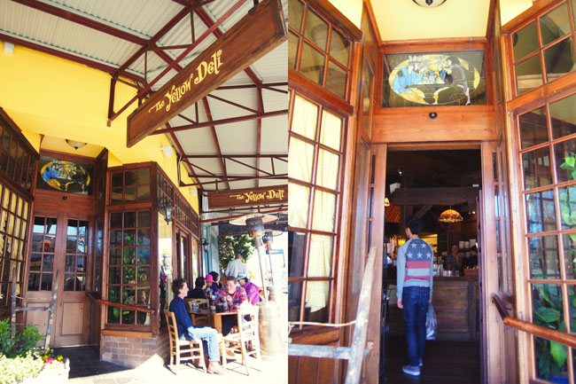
THINK TWICE BEFORE BUYING THE GOODS

